# ****EduTutor AI with IBM – Documentation****

**Project Title:** Health AI with IBM

**Team Member:** Preethi. K

**Team Member:** Preethi. S

**Team Member:** Pradhisha. K

**Team Member:** Praveena. A

**1. Introduction**

**Overview**

EduTutor AI is a personalized **AI-powered learning assistant** built with IBM’s Granite models from Hugging Face. It is designed to create **interactive, customized learning experiences** for students and educators.

The system can generate:

* **Concept explainers** for better understanding
* **Quiz questions** for self-assessment
* Additional features such as summaries, flashcards, and practice problems

The project runs in **Google Colab**, making it accessible without heavy local setups. By integrating **Generative AI**, EduTutor AI aims to bridge the gap between traditional learning and intelligent digital tutoring.

**Objective**

The primary objectives of EduTutor AI are:

* To deliver **personalized learning materials** instantly
* To support teachers in creating **quizzes and assignments** quickly
* To provide **students with tailored study guides**
* To ensure deployment is **low-cost, scalable, and reliable**

**2. Pre-requisites**

Before beginning the project, learners need to be familiar with certain **tools and technologies**:

1. **Gradio Framework**
   * Used to build interactive learning interfaces.
   * Makes AI applications easy to access via a web link.
2. **IBM Granite Models (Hugging Face)**
   * Lightweight and powerful AI models optimized for efficiency.
   * Example: granite-3.2-2b-instruct, suitable for text generation tasks.
3. **Python Programming Knowledge**
   * Required for coding and customizing the AI system.
   * Important libraries: transformers, torch, and gradio.
4. **Version Control with Git/GitHub**
   * Helps store, update, and share the project with others.
5. **Google Colab T4 GPU**
   * Provides free GPU resources.
   * Ensures smooth performance during model training and testing.

**3. Project Workflow**

The EduTutor AI project follows a **step-by-step workflow**:

* **Activity 1:** Exploring the Naan Mudhalavan Smart Interz Portal
* **Activity 2:** Selecting an IBM Granite Model from Hugging Face
* **Activity 3:** Running the Application in Google Colab
* **Activity 4:** Uploading the Project to GitHub

This workflow ensures learners progress from **understanding the portal**, to **building and deploying the AI system**, and finally to **publishing the project** for version control and collaboration.

**4. Activities in Detail**

**Activity 1: Exploring Naan Mudhalavan Smart Interz Portal**

* Open the **Naan Mudhalavan Smart Internz Portal**.



* Log in with credentials.
* Navigate to the **Projects Section** and select **EduTutor AI**.

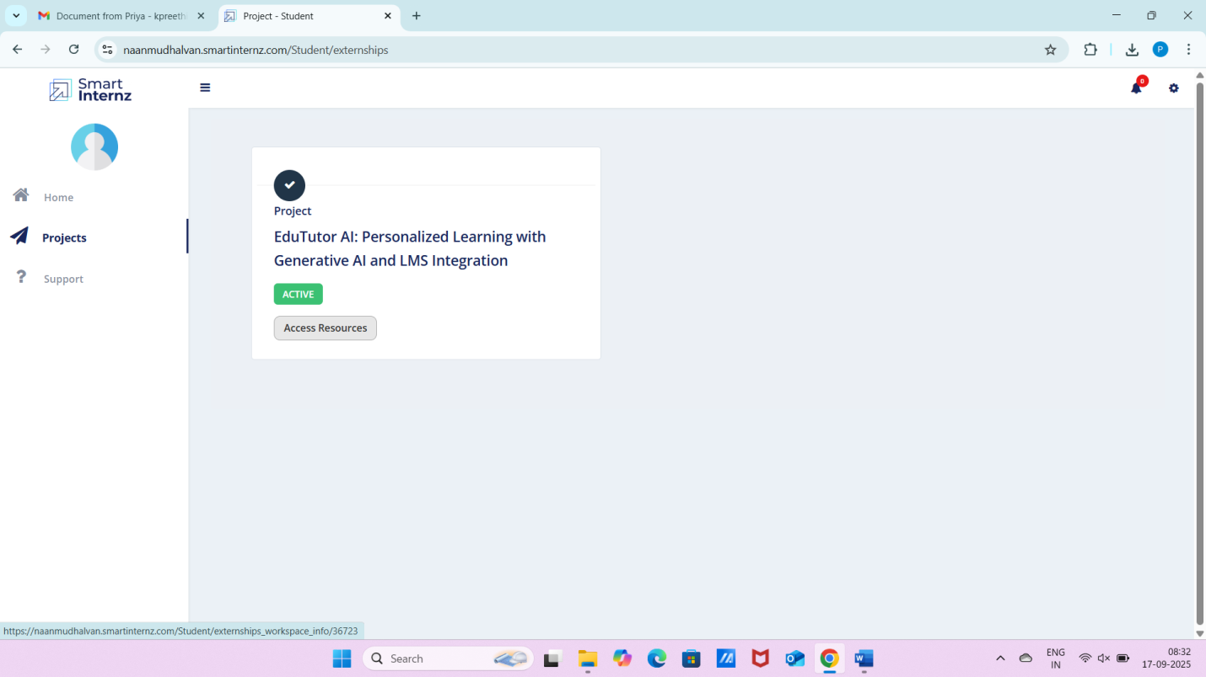

* Go to the **Guided Project Section** for detailed instructions.

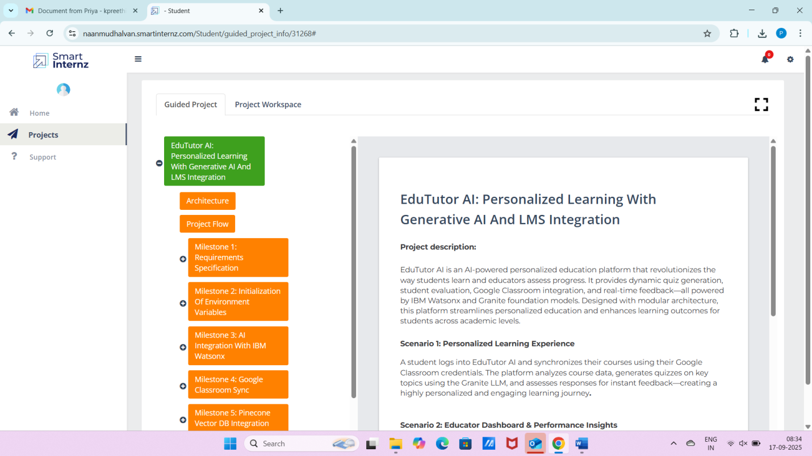

* Open the **Workspace** to check project progress and upload demo links.

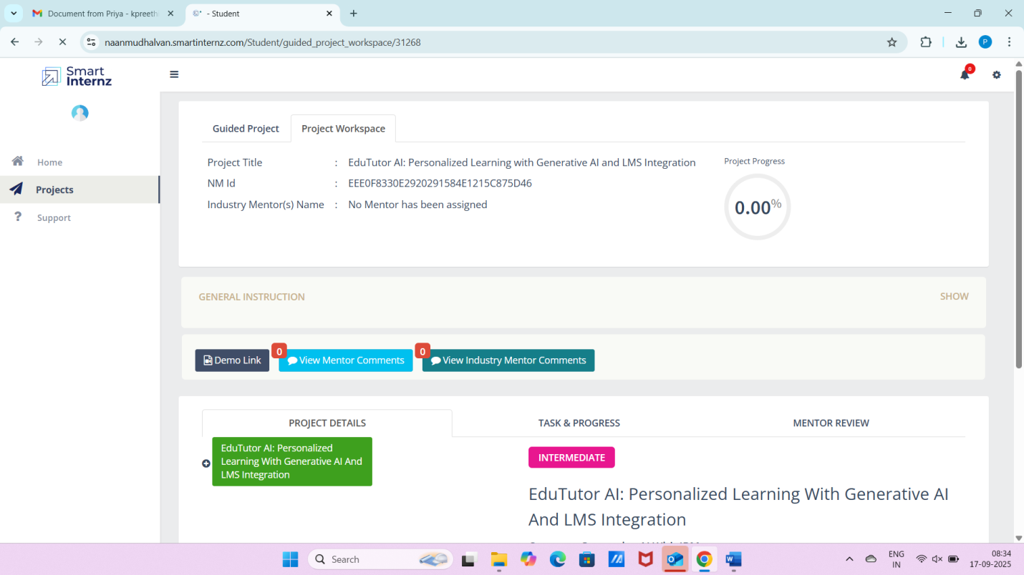

**Activity 2: Choosing an IBM Granite Model**

* Visit the **Hugging Face website**.
* Create a free account.
* Search for **IBM Granite Models**.

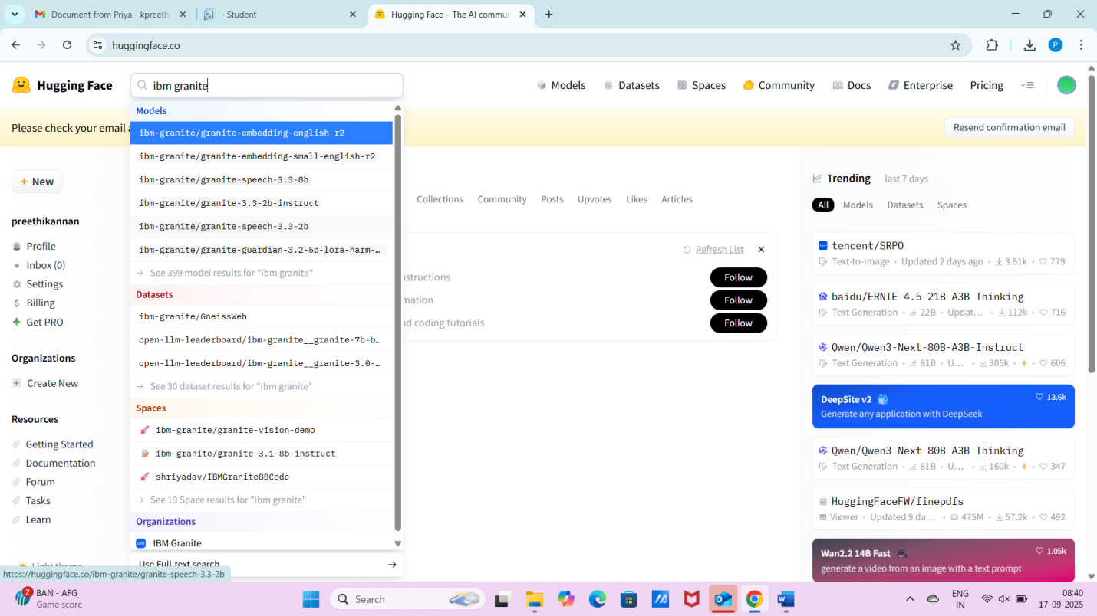

* Select a suitable model, e.g., granite-3.2-2b-instruct, which is **fast and lightweight**.

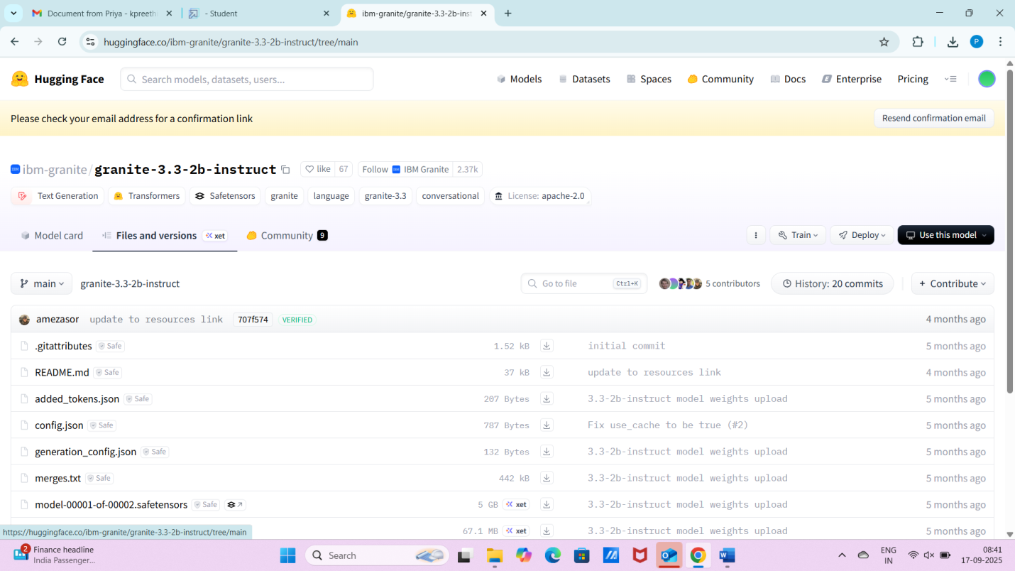

* Use the model in the project for generating learning content.

**5. Implementation and Deployment**

**Activity 3: Running the Application in Google Colab**

1. Open **Google Colab** in a browser.



1. Create a **new notebook** and rename it as **EduTutor AI**.

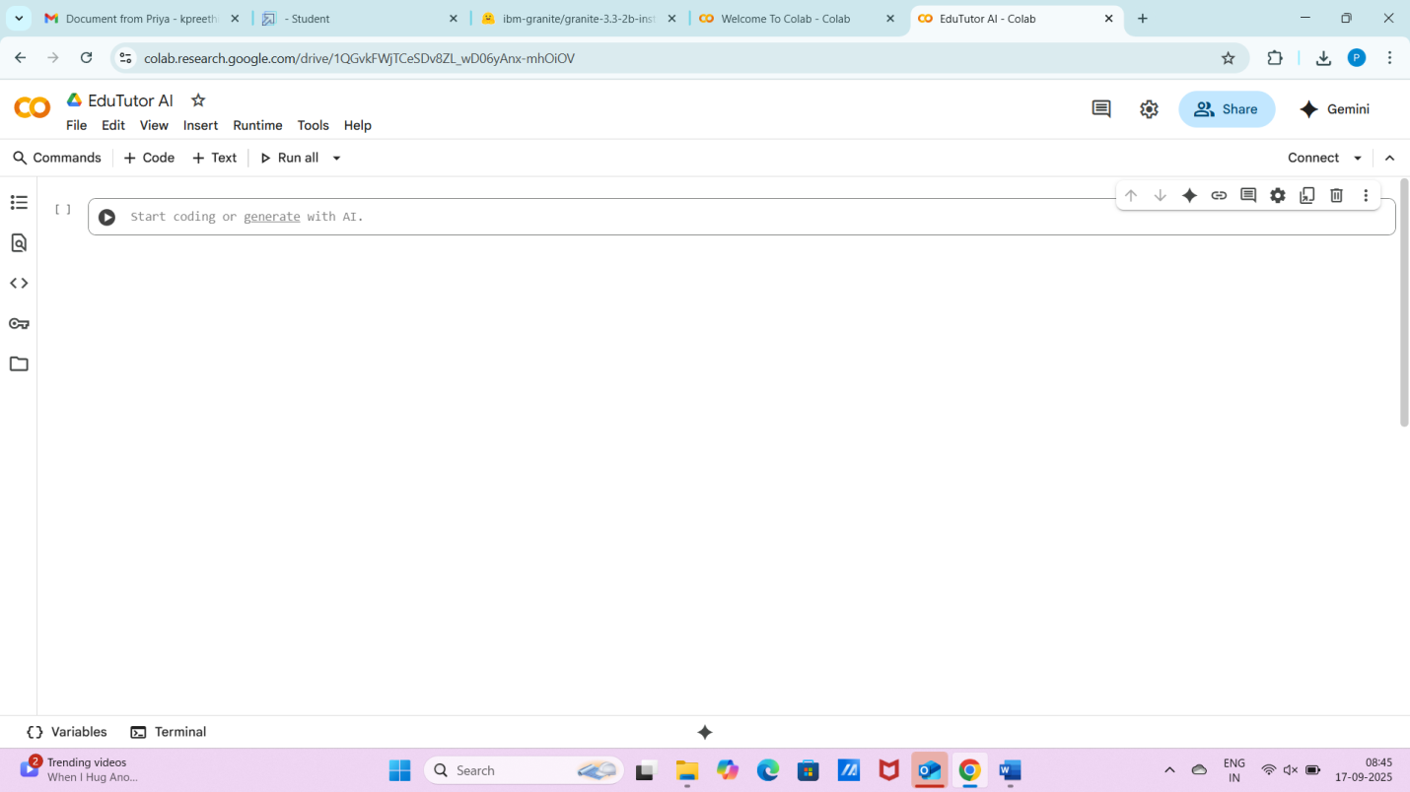

1. Change runtime to **T4 GPU** (Runtime → Change Runtime Type → GPU).

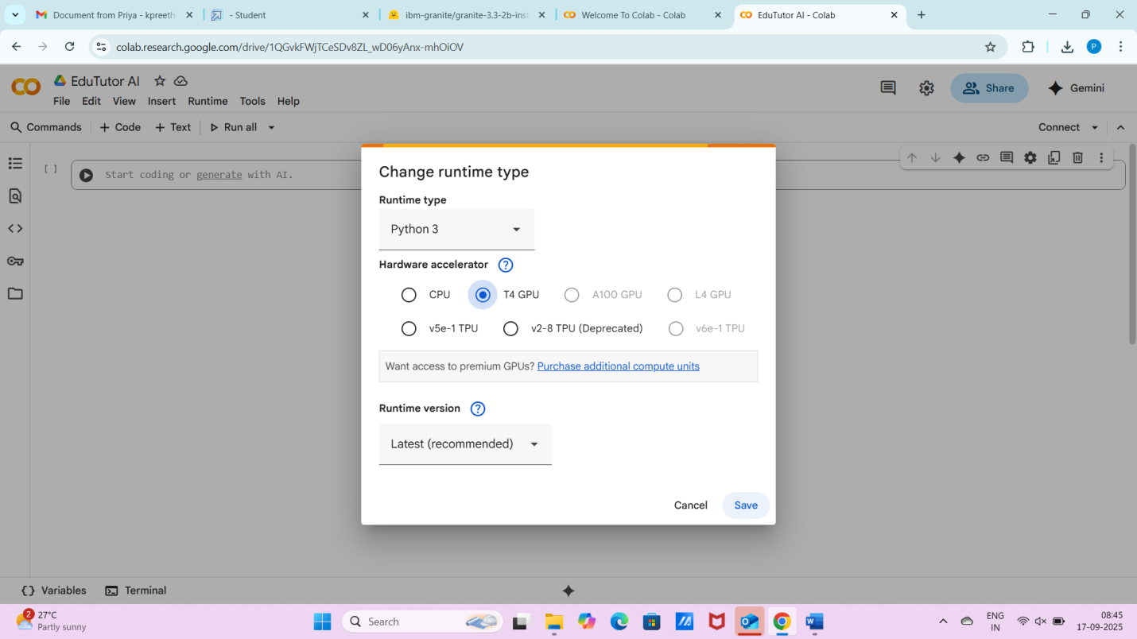

1. Install required libraries:
2. !pip install transformers torch gradio -q

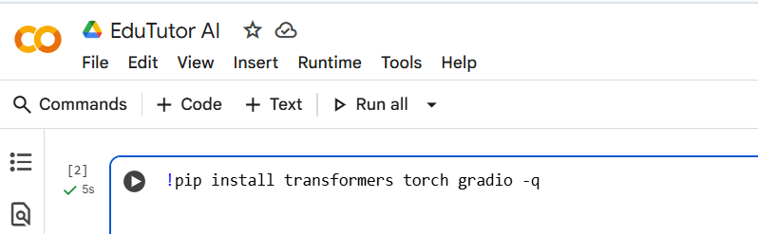

1. Add and run the EduTutor AI code.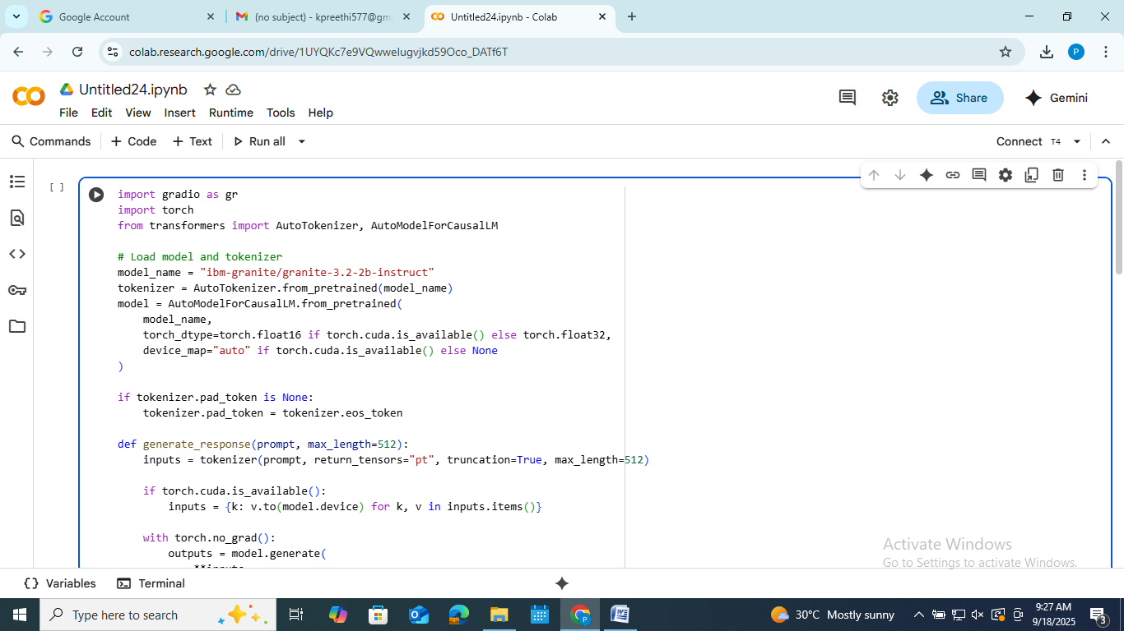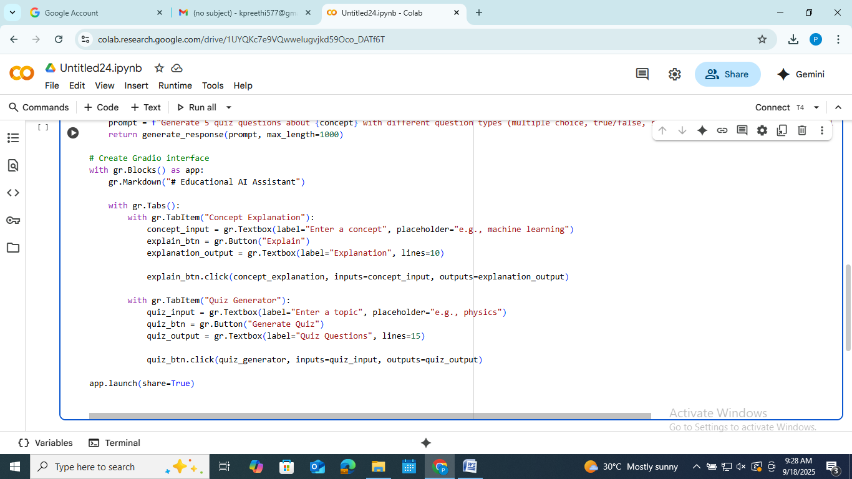7.Once executed, a **Gradio link** is generated. 

Output:Concept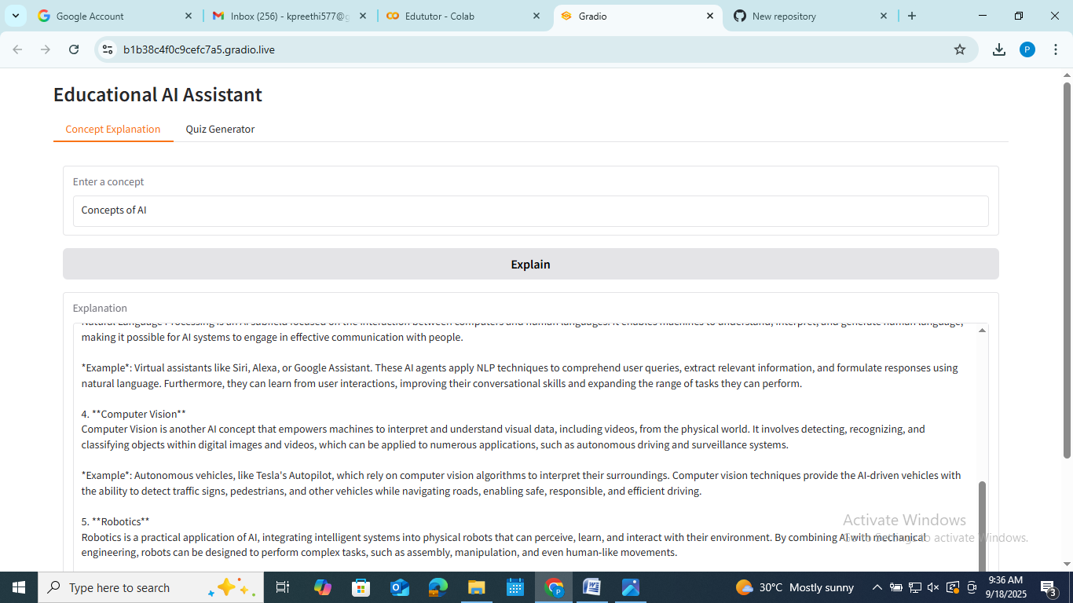

Quiz

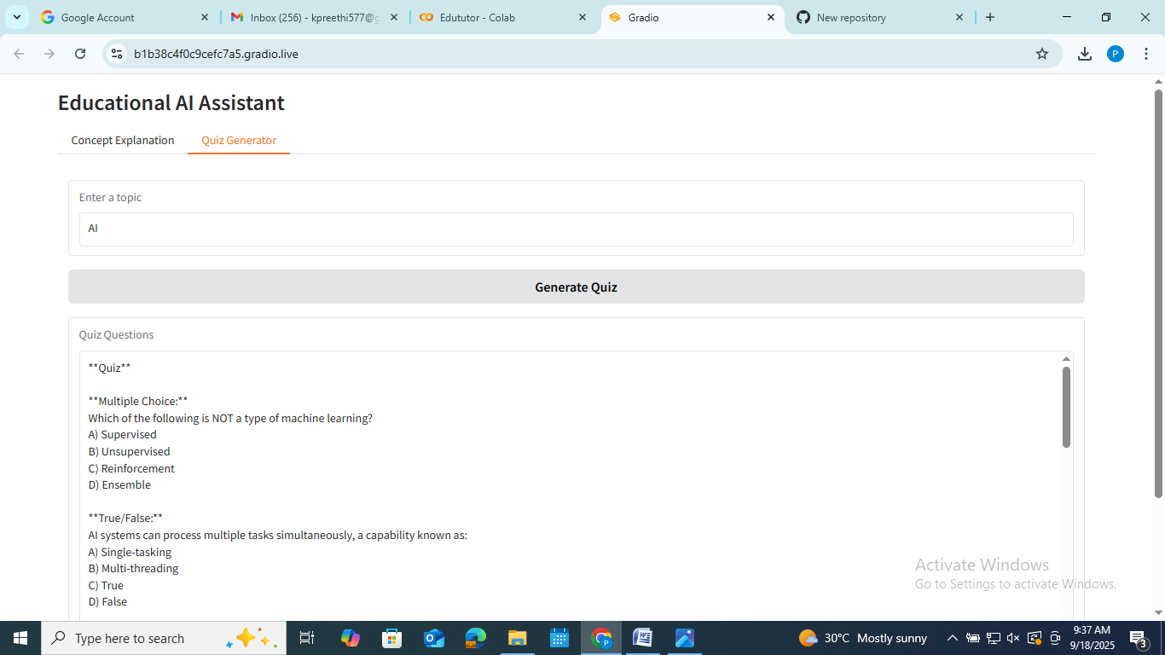

**Activity 4: Uploading to GitHub**

1. Create a **GitHub account** (or log in if already registered). 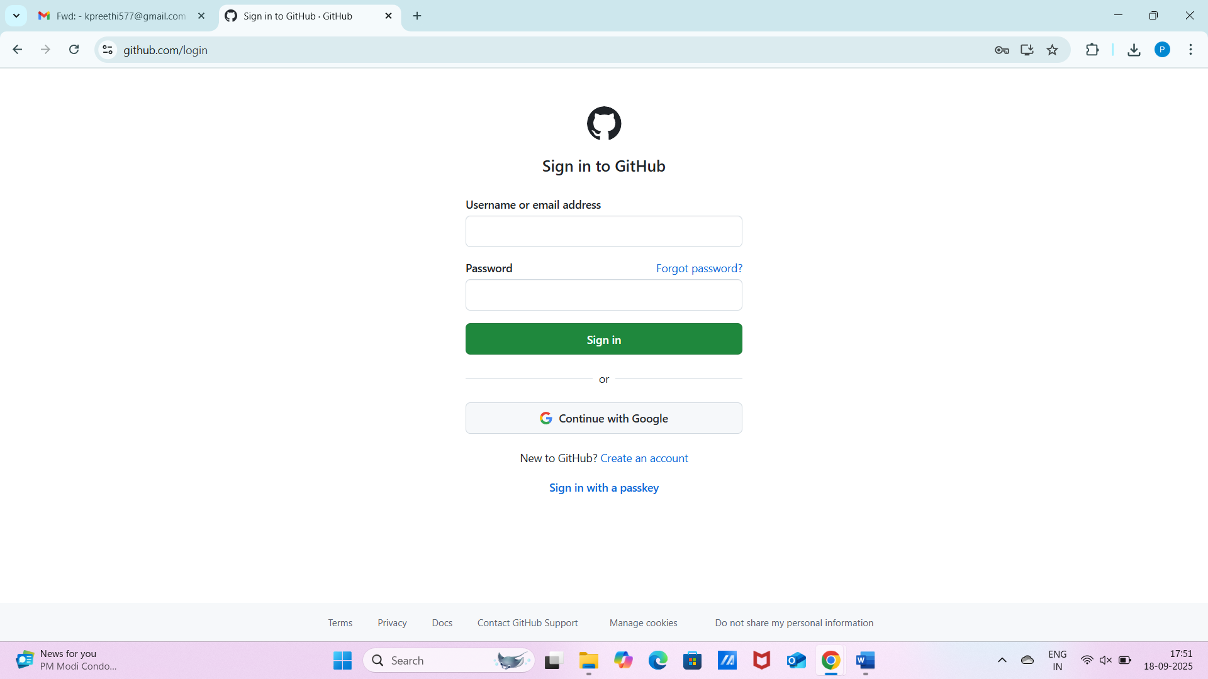
2. Create a **new repository** (e.g., EduTutor-AI-IBM).
3. Enable the **Add README** option.
4. From Colab, download the notebook as .py.
5. Upload it to GitHub using **Add File → Upload Files**. A screenshot of a computer

   AI-generated content may be incorrect.
6. Commit changes to complete the process.

**6. Conclusion**

EduTutor AI showcases how **Generative AI can revolutionize education** by providing **personalized, interactive learning experiences**.

**Key Benefits**

* Generates **study material** instantly
* Helps teachers save time on **content creation**
* Supports students with **tailored resources**
* Easy to deploy using **Google Colab and GitHub**

**Future Enhancements**

* Multi-language learning support
* Voice-based tutoring assistance
* Adaptive quizzes based on student performance
* Integration with **LMS (Learning Management Systems)**